St Oswald’s Kneeler Display – proposed hanging arrangements:

Display will have 21 kneelers laid in landscape (horizontal) format, 3 columns wide by 7 rows high (To be confirmed with Clare Hook):

Each kneeler is 36cm wide by 26cm high by 9cm deep and weighs approx. 850g (0.85kg).
Allowing for 1cm tolerance gap between each kneeler the display would be 110cm wide by 188cm high.
The overall weight of the 21 kneelers would be 17.85kg - say about 18kg.
There are purpose-made art hanging systems such as Locator Extra, STAS and Artiteq. Artiteq appears to offer a reasonable balance between price and quality. All these systems allow more accurate alignment than individual hooks screwed directly to the wall and minimise the work done to the wall. Each kneeler may be hung or removed from the display for maintenance.
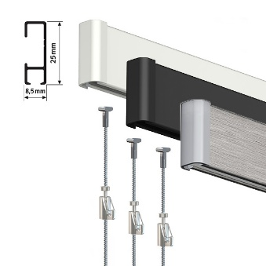
The Artiteq Click Rail Hanging system carries up to 30kg per meter length of hanging rail.
Suggest: Artiteq click rail in classic white, 2m long (to be cut down to the required 1.1m width) with end caps and wall fixings: £52.49
https://www.pictureworld.co.uk/product/artiteq-click-rail-lock-hanging-set/
6 lengths of 2m solid slider hanging wires in stainless steel at £7.56 each: £45.36
42 Artiteq Heavy Brass hooks at £2.40 each: £100.80

(Cheaper lighter hook option, still capable of carrying kneelers, at around £65 for 50 hooks).
Estimated Total price £198.65. There might be some savings involved with buying multiple items.

Note that we would need someone to sew two loops onto the rear top corners behind each kneeler to allow them to be hooked onto the hanging system. The current loops are placed centrally on the narrow edge for hanging in the other direction. Cost dependent on materials used but unlikely to be high if volunteer(s) prepared to do the sewing work.

In addition, a 1.2m wide by 0.15m deep wooden shelf is proposed to be fitted over the rail, above the kneelers to reduce the impact of dust settling on them. Estimated cost approx. £30 to £50.

