Photos to show where kneeler display will be located

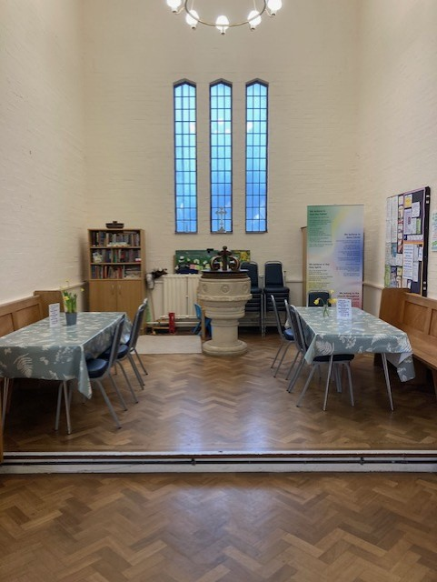

- Display will be on the left wall. Bottom of the display to be no lower than the height of the bookcase on the back wall.

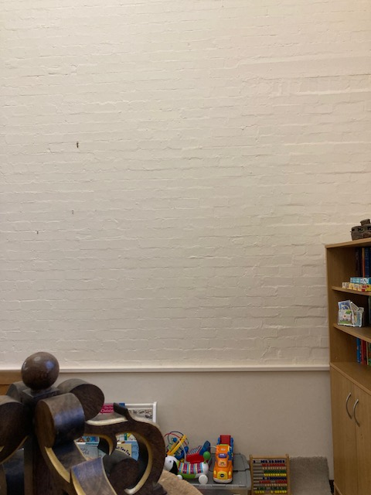

- Wall where the display will be located

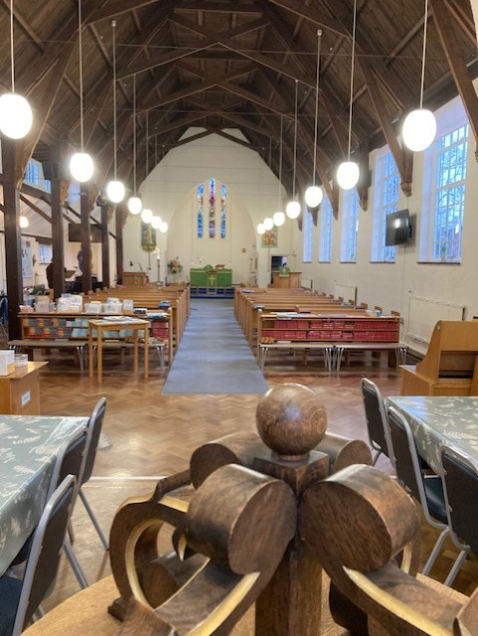

- View from the area where the display will be located into the church.

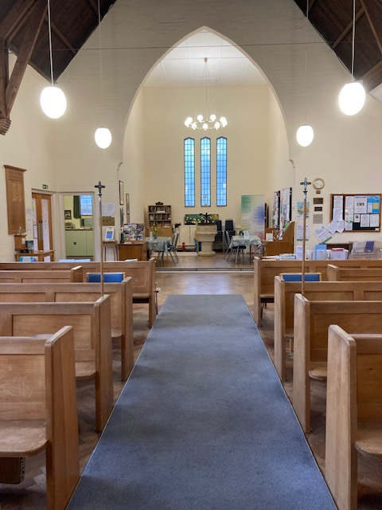

- View from the middle of the church looking back to where the kneeler display will be on the left wall by the font.

