ARTITEQ Click Rail Lock Hanging Set 200cm max. 30kg/m
£52.49 – £55.73Price range: £52.49 through £55.73

The Click Rail Lock Set offers increased security, preventing the artwork from being removed from the system easily.

PRODUCT INFORMATION
rail length: 200cm
colour: white, black, grey
wire: Solid Slider 2mm steel
hook: Micro/Auto LOCK

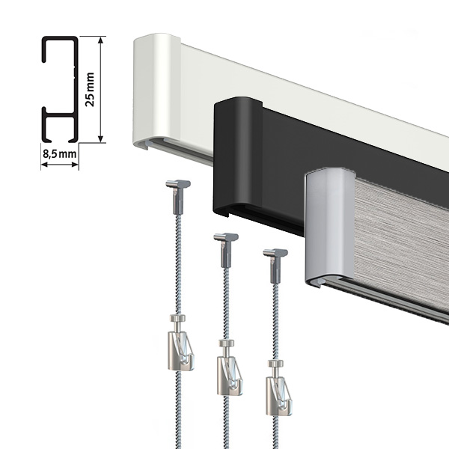

ARTITEQ Click Rail Lock Hanging Set 200cm max. 30kg/m
The Click Rail Lock Hanging Set offers your picture hanging system increased security. Solid Slider Wires connect to the rail from either end of the system. It means it’s not possible to remove them easily. Micro and Auto Grip LOCK Hooks are equipped with a clamp that prevents the artwork or picture from being lifted off the hook. That’s a perfect solution for small galleries, schools, and churches. In the home and office environment, this set-up prevents the artwork from falling off the wall (e.g. if accidentally knocked off) in narrow corridors, staircases etc.

What’s included
ARTITEQ Click Rail 200cm max. 30kg/m (Qty 1)
End Cap (Qty 2)
Installation Bracket (Qty 6)
Screw 3.5mm 45mm (Qty 6)
Wall Plug 6mm (Qty 6)
Solid Slider Hanging Wire 150cm 2mm steel max. 22kg (Qty 3)
Auto Grip LOCK Hook max. 15kg (Qty 3) OR Micro Grip LOCK Hook max. 20kg (Qty 3)

The Click Rail
ARTITEQ Click Rail Lock Set is available in 200cm length. ARTITEQ rails are made from durable aluminium and can be cut to size with a hack saw. End caps protect rail ends. End caps have a small gap in them for connecting wires. It means you can install the rail snugly wall to wall if needed. Please ensure you leave 5mm on each side for the end caps when cutting.

Four finishes
ARTITEQ Click Rail picture hanging system is available in 4 finishes: matt black, classic white, pure white, and brushed grey. The rail can be cut to size with a metal saw (~2 minutes per rail). The Click Rail takes up to 30kg of weight per meter. If you fit rails side by side, install one of the brackets behind where the two rails join. This will align them nicely on your wall. Other brackets should be fitted every ~40cm/8in. The installation involves drilling three holes per rail meter (6mm drill). There is no other DIY required after that is done.

Pure vs classic white
The pure white happily accepts most types of paint so that you can match its colour with your walls. You can also fit it as-is. It’s a bright shade of white. The classic white finish is usually referred as off-white, warm shade of white.

Corner connectors
If you intend to install the Click Rail around corners, you will need to add Corner Connectors (not included in the set) to your order. They work as an inside and an outside connector. It is hardly visible when used as an inside connector as it is placed behind the rails. This connector allows you to slide wires around corners without disconnecting them. Available in white, black and grey.

Solid Slider Wire
The Solid Slider Hanging Wire easily hangs pictures and artwork on a wall. This wire connects to a rail by inserting it from either end. If the wire is too long, you can cut the excess with a sharp cutting tool or curl it behind your picture or artwork if you need it in the future. ARTITEQ Solid Slider Hanging Wire also provides an extra layer of security to your system as it can be removed only by sliding it off the end of your rail.

Auto Grip LOCK Hook
The Auto Hook is made of steel, takes up to 15kg and can be used with 2mm perlon or steel wires. We recommend using two wires and two hooks to double the maximum weight for larger artwork. It is also possible to hang several pictures on a single wire. It all depends on the size of the wall and the pictures you are hanging. The Lock allows you to secure your frame so that it doesn’t accidentally slip off or isn’t removed from the system by not authorised persons.

Micro Grip LOCK Hook
The Micro Grip hook represents the newest generation of hooks. A high-quality plastic reinforced with fibreglass leads to a 70% reduction in the use of materials compared with previous generations of this hook. It takes up to 20kg and can be used with 2mm perlon or steel wires. The Lock allows you to secure your frame so that it doesn’t accidentally slip off or isn’t removed from the system by not authorised persons.

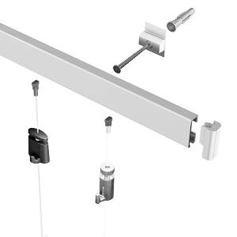

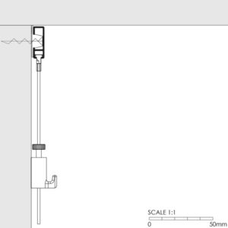

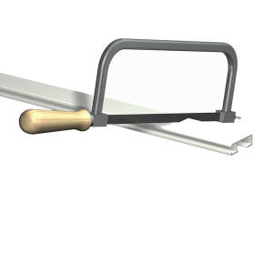

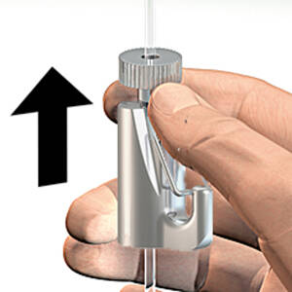

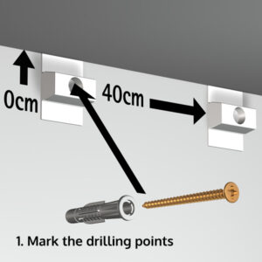

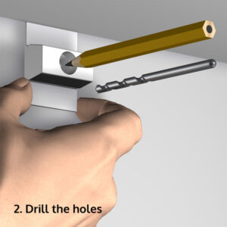

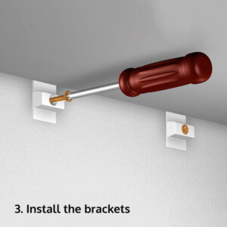

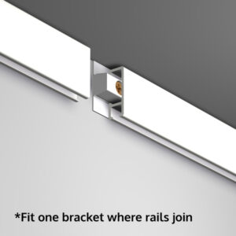

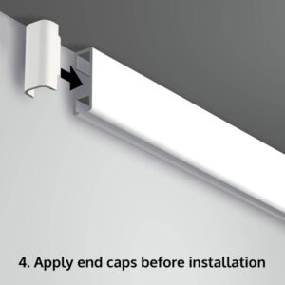

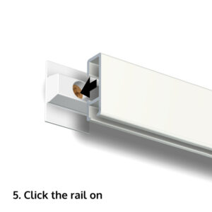

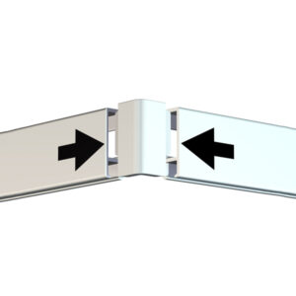

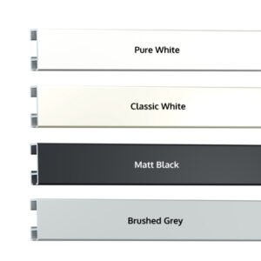

Related products
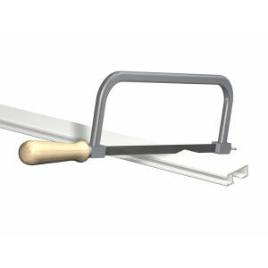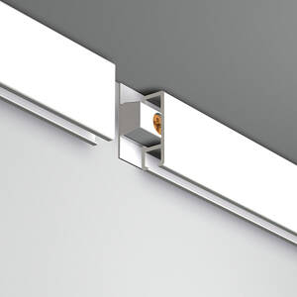
Shopping List
Rail cutting service (up to 5 rails, 200cm-300cm)
£4.80

Not all walls are of the same size, so sometimes, the rails need to be cut to different lengths to fit nicely in your space.

PRODUCT DESCRIPTION
price: up to 5 rails
service: cutting
off-cuts: on request
returns: not accepted
Add to basket
-10%
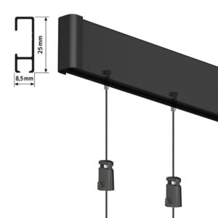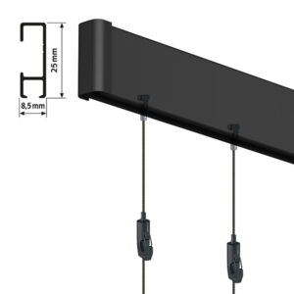
Shopping List
ARTITEQ Click Rail Vogue Hanging Set 200cm max. 30kg/m
£42.61 – £52.00Price range: £42.61 through £52.00

The Click Rail Vogue Set brings very trendy black finish to picture hanging. Black rail, steel wires and picture hooks.

PRODUCT INFORMATION
rail length: 200cm
colour: black
wire: Twister 1mm black
hook: Micro/Lock Grip
Select options
This product has multiple variants. The options may be chosen on the product page
-10%
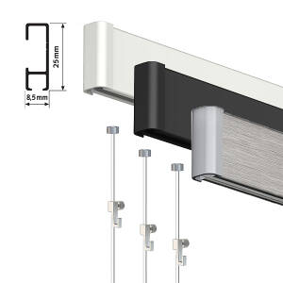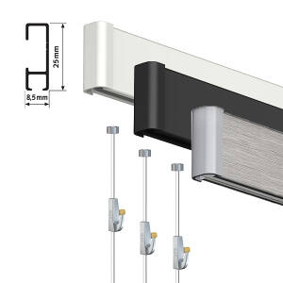
Shopping List
ARTITEQ Click Rail Art Hanging Set 200cm max. 30kg/m
£28.94 – £33.70Price range: £28.94 through £33.70

Excellent hanging system for a variety of pictures. Hang several frames per wire. Or just one. Be in control.

PRODUCT INFORMATION
rail length: 200cm
colour: white, black, grey
wire: Hexagon 2mm perlon
hook: Mini/Heavy Brass
Select options
This product has multiple variants. The options may be chosen on the product page
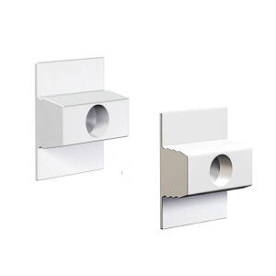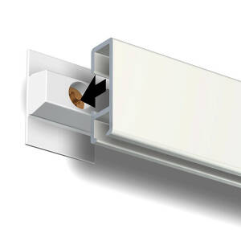
Shopping List
ARTITEQ Click Rail Installation Bracket (Qty 10)
£3.60

Required for the installation. Standard brackets are for regular walls whereas Extra Grip for uneven walls.

PRODUCT INFORMATION
type: standard, extra grip
installation: every 40cm
compatibility: Click Rail
required: yes
Select options
This product has multiple variants. The options may be chosen on the product page
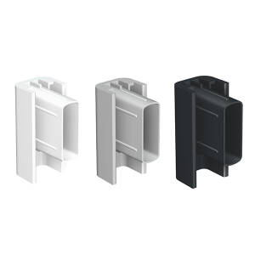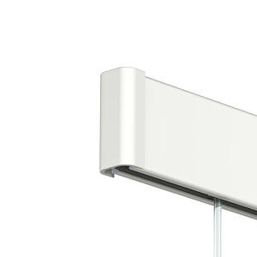
Shopping List
ARTITEQ Click Rail End Cap (Qty 2)
£0.96

The end caps protect the ends of a rail. If you are cutting rails into shorter lengths, add extra ones to your order.

PRODUCT INFORMATION
colour: white, grey, black
size: 25mm(H) 6mm(W)
compatibility: Click Rail
required: yes
Select options
This product has multiple variants. The options may be chosen on the product page
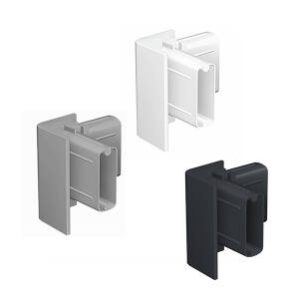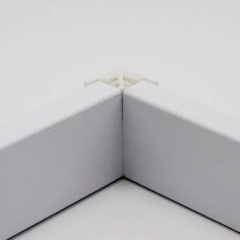
Shopping List
ARTITEQ Click Rail Corner Connector
£0.90

Joins Click Rails around corners at around 90 degrees. It works as either an inside and outside corner connector.

PRODUCT INFORMATION
colour: white, grey, black
corners: inside/outside
compatibility: Click Rail
angle: 85-95 degrees
Select options
This product has multiple variants. The options may be chosen on the product page

Settings
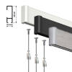
ARTITEQ Click Rail Lock Hanging Set 200cm max. 30kg/m
£52.49–£55.73Price range: £52.49 through £55.73Select options

